***Gyroscope solar system***

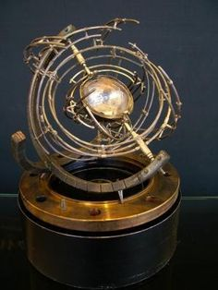

*Solar system gyro is also known as the solar system gyroscope. This is a physical toy, as well as an interesting decor, suitable for the office space. The product is mainly made of plastic material. See the product video below the detailed description. Suitable as a gift for friends, colleagues, students, lovers of unique and scientific decorations*